# Objective:

* Determine the Oracle requirements for a new database installation
* Install Oracle 11g Express
* Getting Started with Oracle 11g Express
* Connecting SQL Developer to Oracle 11g Express

## Due Date:

The lab is due no later than Friday Oct 6th. You must **hand in** PDFs of your work on all sections to the dropbox on D2L.

Scoring:  
Lab is out of 30 and has 2 bonus points.

# Part 1 – Planning Exercise

## Description:

Your company, CGI, has been contracted by Erehwon Pharmaceuticals Inc. (EPI) to deliver a plan to modernize their data processing system. As one of the Senior DBAs at CGI your role is to determine the database requirements to support this new system.

EPI is a prescription drug manufacturing company and is highly regulated by the government. All their systems operate on a local LAN, with no external access (i.e. no accesses to the internet). There are a total of 2000 PC’s in EPI, all of which will need to connect to the new system for either online transaction processing or for management decision support services. It is essential that EPI maintain very detailed records of all customers, drugs, ingredients, recipes, manufacturing batches, orders and order batch details.

The following sizing information has been provided by EPI:

* + 3,000,000 customers @ 1000 bytes each
  + 10,000 drugs @ 400 bytes each
  + 200,000 ingredients @ 200 bytes each
  + 10,000 recipes averaging 20 ingredients each @ 150 bytes per recipe per ingredient
  + 1500 manufacturing batches of drugs produced per day @ 500 bytes each
  + 9,000 orders per day @ 100 bytes each
  + 50 order-batch details average per order @ 70 bytes each

Note that EPI expects to increase the number of drugs it produces by 20% per year for each of the next 2 years. They also expect to increase the number of customers and orders by 30% per year over the same 2 years.

## Requirements:

Based on the above description, determine the Oracle requirements to support the new EPI system. Include:

* + what Oracle license you would recommend,
  + the overall architecture of the Oracle system,
  + the number of server(s) required and
  + an estimate on the disk space requirements by the end of the two years.

Make sure you provide an adequate explanation to justify your plan. You will need to refer to your class notes on Chapter 4 Planning. *(10 Marks)*

Use MS Excel to produce a detailed report showing the data requirements for each of the information categories along with the totals for the entire database after the two years. Note - Use 1,000 as the divisor when converting bytes to KB/MB/GB. *( 5 Marks)*

Use the report template provided below to provide your recommendations and justifications.

## Report Template:

|  |  |  |  |  |  |
| --- | --- | --- | --- | --- | --- |
| **Oracle Database Requirement Document** | |  |  |  |  |
|  |  |  |  |  |  |
| **Oracle Licence**  **Recommendation** | **Architecture**  **Recommendation** | **Server**  **Recommendations** | **Storage  Recommendations** | | |
| **Enterprise Edition** | **Maximum available architecture** | **Exdata** | **Disk space recommended for optimal usage would be:** | | |
| **Justification** | | | | | |
| Being that EFI will be dealing with a massive amount of data on a regular basis and is regulated by the government on site Exdata servers would be most secure. As far as a license goes the only viable option would be the enterprise edition, it is the only one that can manage the amount of data needed to maintain a database of such magnitude. The maximum available architecture is highly recommended due to the availability and performance gains. The recommended amount of space would be 83Gb. This amount is based off of the increases over the next two years from customer base and the drugs the company will produce. As the company continues to grow Exdata will continuously meet the requirements for EFI. | | | | | |

Include a screenshot of your spreadsheet below.

|  |
| --- |
|  |

# Part 2 – Install Oracle 11g Express

## Oracle 11g Express:

Oracle Database 11gExpress Edition (Oracle Database XE) is an entry-level, small-footprint database based on the Oracle Database 11g Release 2 code base.  It's free to develop, deploy, and distribute; fast to download; and simple to administer. It is a great starter database for DBAs who a database for training and deployment. XE will only store up to 11 GB of user data, use up to 1 GB of memory and only use one CPU on the host machine.

Oracle Express Edition web site: <http://www.oracle.com/technetwork/database/database-technologies/express-edition/overview/index.html>

## Requirements:

1. Download the file OracleXE112_Win64.ZIP from the D2L site for the course or get it from the USB stick that is in the lab.

For Windows x32 or Linux x64 versions of the software go to Oracle Express Edition web site.

Extract all the files from the zipped file into a temporary folder. Open the temporary folder, then open the **DISK1** folder and run **setup.exe**. If the User Account Control window pops up asking if you want to allow this app to make changes to your device, click on **Yes**. The install should take 2-3 minutes on the lab computers (i7 models). Take the defaults for all the options and remember the passwords you entered for the SYS and SYSTEM accounts. The target directory should be named **oraclexe**.

* + In the *Oracle Database 11g Express Edition – Install Wizard* welcome window, click **Next.**

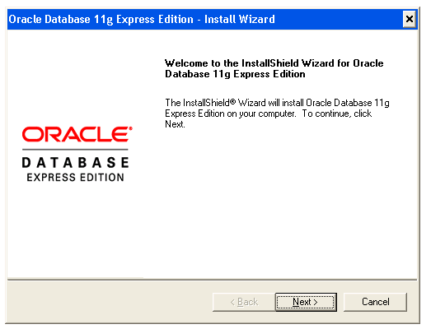

* + In the *License Agreement* window, select **I accept the terms in the license agreement** and then click **Next**.
  + In the *Choose Destination Location* window, either accept the default or click **Browse** to select a different directory. Then click **Next**.

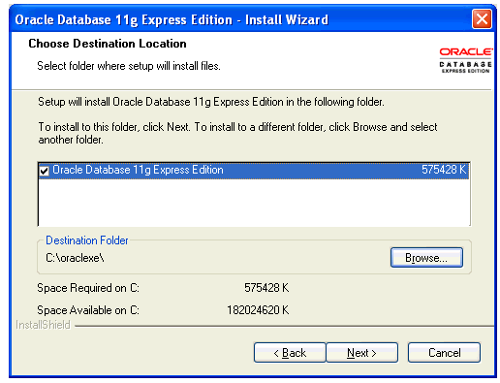

* + If you are prompted for a port number, then specify one. The following port numbers are the default values:
    - **1521** : Oracle database listener
    - **2030** : Oracle Services for Microsoft Transaction Server
    - **8080** : HTTP port for Oracle Database XE graphical user interface
  + In the *Specify Database Password* window, enter and confirm password for the **SYS** and **SYSTEM** database accounts. Then click **Next**.

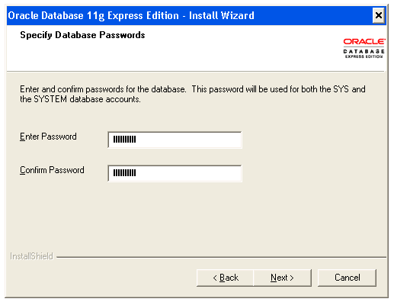

* + In the *Summary* window, review the installation settings and if you are satisfied, click **Install**. Otherwise, click **Back** and modify the settings as necessary.

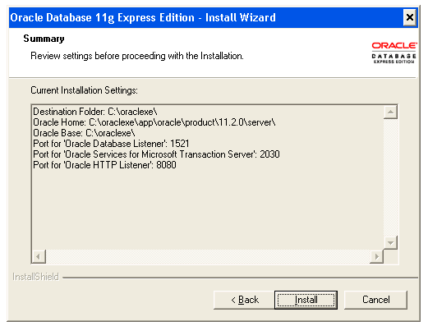

1. Once the installation is complete. Look at the tree structure of the target directory from step 1 that Oracle Express was installed in.
   * What folder are the database files stored in? *(1 Mark)*
   * What are the database files in that folder? *(1 Mark)*

**Warning** – do not edit or rename these files.

|  |  |
| --- | --- |
| **Oracle Database Folder** | **C:\oraclexe\app\oracle\product\11.2.0\server\** |
| **Oracle Database Files (names)** |  |

1. Look at the Windows menu start options (). You should now see Oracle Database 11g Express Edition as a new group. Select the **Start Database** () option from the Oracle menu group. If the User Control Access window pops up, just click Yes to allow access. A command line window will open saying that “The OracleServiceXE service is starting………….” When the database startup is complete you will get “The OracleServiceXE service was started successfully.”

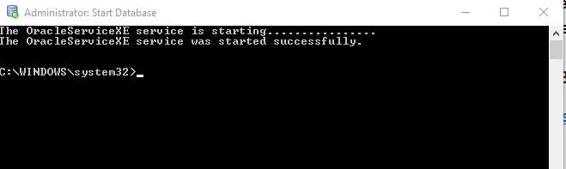

Using Task Manager, identify the Oracle processes that are now running. *(1 Mark)*

|  |  |
| --- | --- |
| **Oracle Processes** | Oracle RDBMS Kernel Executable  Oracle TNSLSNR Executable |

1. Select the **Stop Database** (  ) option from the Oracle menu group. A command line will open saying the “OracleServiceXE service is stopping …….”, when the database is stopped you will get “The OracleServiceXE service was stopped successfully.”

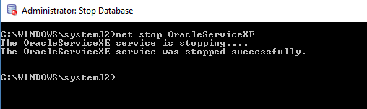

Using Task Manager, identify any Oracle processes that are still running. *(1 Mark)*

|  |  |
| --- | --- |
| **Oracle Processes** | Oracle TNSLSNR Executable |

1. Start up the database again.
2. Select the **Run SQL Command Line** (  ) option from the Oracle menu group. Then enter the command **connect / as sysdba** to connect to the database. Then answer the following questions, showing the SQL you used:

|  |  |
| --- | --- |
| **How many users have already been created? *( Bonus 2 Marks)*** | **select count(username) from all_users;**  **16** |
| **What tables are in the HR schema? *(2 Marks)*** | **select table_name from all_tables where owner = 'HR';**  **REGIONS**  **LOCATIONS**  **DEPARTMENTS**  **JOBS**  **EMPLOYEES**  **JOB_HISTORY**  **COUNTRIES** |
| **How many rows are in the HR departments table? *(1 Mark)*** | **select count(*) from hr.departments;**  **27** |

1. Try connecting with user HR and password HR. What happens? (*1 Mark*)

|  |
| --- |
| **Connect HR/HR**  **The account is locked** |

Connect back in to Oracle as the SYSDBA. Note- you can use the up and down arrows to cycle through your command history.

Run the command **alter user hr identified by hr account unlock,** then trying connecting to HR again and look at some of the tables in the HR schema.

# Part 3 – Getting Started with Oracle 11g Express

1. From the Oracle menu group, select the **Get Started** (  ) option. This will bring up the following screen in your browser.

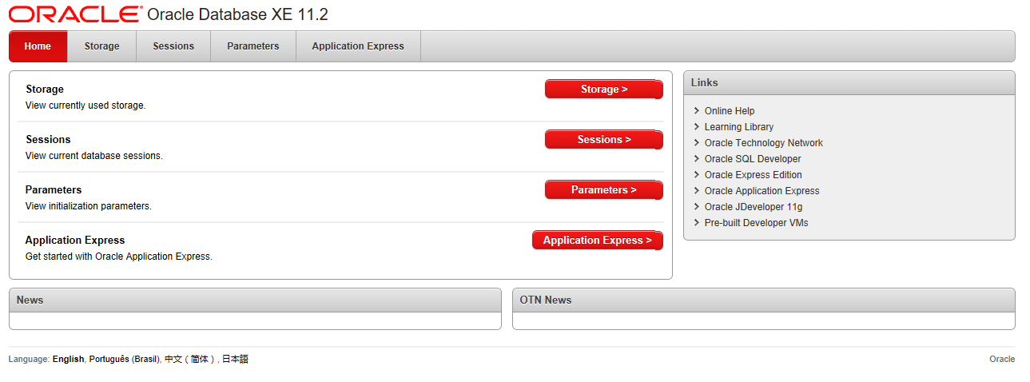

Note – If you are running any port blocking software or VPN software and the browser can’t bring up the above window, disable that software.

If the window fails to come up, first try rebooting the machine and then start the database again and then selecting the Get Started again.

If that doesn’t work, then bring up the **Control Panel**, select **System and Security**, select **System**, select **Advanced Settings**, select **Environment Variables**, and then create a new environment variable called HTTPPORT and set it to 8080. After you define this variable, then reboot your computer.

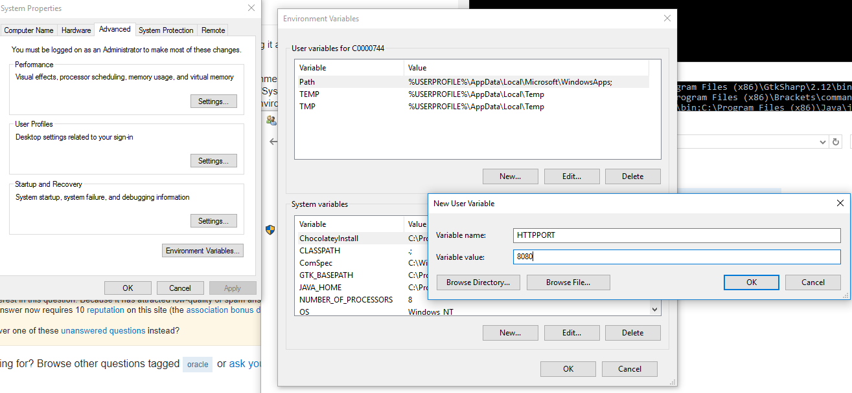

1. Take a look at the information under the **Storage** window. Login as SYSTEM. What tablespaces are displayed here and what physical file do they correspond to from Part 2, question 2. What file does not have a tablespace attached to it and why?

|  |  |
| --- | --- |
| **List tablespaces and matching physical files *(2 Marks)*** | **Sysaux – sysaux.dbf**  **System – system.dbf**  **Undotbs1 – undotbs1.dbf**  **Users – users.dbf**  **Temp – temp.dbf** |
| **Physical table with no tablespace and why? *(2 Marks)*** | Control.dbf is the pointer to the rest of the files so oracle knows which ones to load |
| **What tablespace is the employee table stored in and how many rows does it have. *(1 Mark)*** | **Users – and it has 107 rows** |

# Part 4 – Connecting SQL to Oracle 11g Express

1. Create a new connection in SQL Developer to your new Oracle Express database. Connect with the hr user.

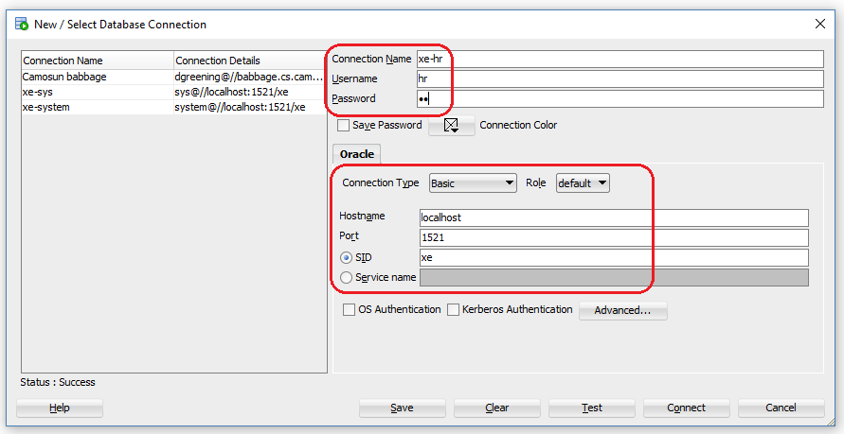

1. Create another new connection in SQL Developer for the **sys** account making sure you given them a SYSDBA role.
2. From the main menu select **View** and **DBA**. This will bring up a new DBA panel in the lower left. Click on the new panel’s green plus sign to add your new **sys** connection and select **OK**. From the DBA panel expand your system connection. Select **Storage**, and then select **Tablespaces**. Take a screen shot of the Space, Files and Free Space windows and then paste the images below: (2 Marks)

|  |
| --- |
|  |

Which tablespace has the least amount of freespace left and what percent is it at? *(1 Mark)*

|  |  |
| --- | --- |
| **Tablespace with least amount or free space & amount free** | **System – 6 Mb free** |

What is the block size for the USERS tablespace? *(1 Mark)*

|  |  |
| --- | --- |
| **USERS tablespace block size** | **8192** |

1. Stop the database service when you are done.

# Appendix – Oracle Database Express Edition – Database Storage Structure

Oracle Database Express Edition is composed of the following storage structures:

* + **Logical structures** such as tablespaces are created and recognized by the database only and are not known to the operating system.
  + **Physical structures** are those that can be seen and operated on from the operating system, such as physical files that store data on disk.
  + **Recover-related structures** such as redo logs and daabase backups are used to recover the database after an operating system failure, Oracle instance failure, or media (disK) failure. Recovery-related structures are stored in an automatically managed disk storage area called the *flash recovery area*.

The database is the collection of logical and physical structures that together contain all the data and metadata for your application. The database automatically manages all contents of the flash recovery area.

